5.21

Last week issue:

1. Delta limits – was overly shorting in bull markets. This week keep checking delta limits
2. Entrance threshold: change to 10/90 to guarantee better trading. Last week lost money in trade pnl – need to ensure positive trading PnL first to sustain auto trading.
3. Halt inventory trading, this didn’t make money, and this caused a lot of accumulation – focus on percentile trading and keep monitoring delta limits.
4. Trade less, trade at more key positions
5. Once auto trading makes money, you can have more aggressive delta limits. For example, more delta accumulation during bear sentiment. (increasing positive delta + bullish limit in bear scenario)

5.22

1. stocks – hold long, adjust holdings periodically, hold the best stock in each industry, keep constant size of 70%
2. futures – auto trading, hedge, avoid going net short – either positive or flat.
3. Never go over full position on any product
4. Never use margin
5. Don’t touch stocks for daily delta rebalance -> adjust overall delta with futures.
6. Observe MA carefully
7. Keep delta within a small positive/negative band (like -500k to 500k)
8. Good stocks will outperform the index in the long run. Pick the best and strongest stocks in each sector. Most famous, best growth and best cash flows.
9. No buy today and sell tomorrow for stocks.

Reflection on this year:

1. Jan17-Feb 6, 2.5mm delta was bought at the highest level (drastic delta change), lost 250k for trading within one month, kept increasing delta when the market just started coming down. No delta limit/delta control, saw it coming down and kept buying on margin.
2. Future was same direction as stocks, max delta was 7mm, now it is less than 10% of that figure. Futs were moving by 10k USD everyday (on 48 futs for over a month in Feb)
3. Heavy margining was used on stocks, paying interest for 5k and didn’t work.

5.24.2018

5.25.2018

Work on PD_ACC and PD_DECC

5.26

Weekly review:

Fut: up 43k.

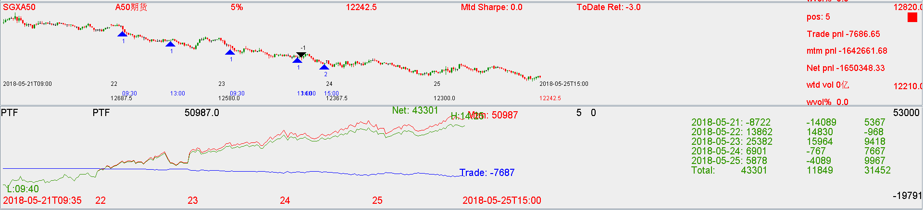

Cash:

Down -43k on mtm.

